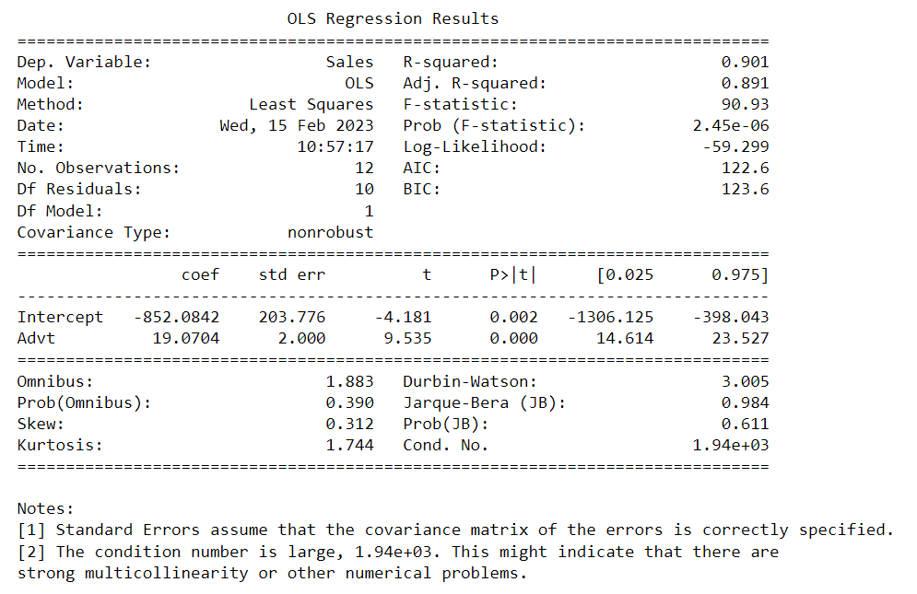

If the P-value is Greater than Level of significance (0.05) then we can drop those features

Target variable

**R-Squared**:- R-Squared also known as the coefficient of determination, It measures the proportion of variation in your dependent variable (Y), Explained by your independent variable (X)

For example, an R² value of 0.901 means that 90.1% of the variation in the dependent variable is explained by the independent variable in the model.

In other words, R² is a measure of how well the regression model fits the data. It is often used as a goodness-of-fit measure to assess the performance of a model. However, it should be noted that R² only measures the goodness of fit of a linear regression model

The main problem with R-Squared is that it will always remain the same or increases as we are adding more independent variable, therefore to overcome this problem,

An Adjusted R-Squared came into picture by penalizing those adding independent variable that do not improve your existing model.

**F-statistic:-** It compares the variability of the data explained by the model to the variability of the data not explained by the model

**P-value:-** If the p-value is greater than the level of significance (0.05), it means that the null hypothesis cannot be rejected. The null hypothesis is typically that the coefficient for a given independent variable is equal to zero, indicating that the variable has no effect on the dependent variable.

Therefore, if the p-value is greater than the level of significance, it suggests that there is not enough evidence to support the claim that the independent variable has a significant effect on the dependent variable, and the variable can be dropped from the model.

**Coefficient:-** For one unit change in my x-axis what is the change in my y-axis

Ex:- Coefficient = 19.07 (if 1rs change in advt then 19.07rs will change in sales)

**Intercept:-** The line where the point cuts the y-axis is intercept

Ex:- When the advt = 0 then what is the sales (for example when advt = 0 then sales = -852.08)